CARDIOLOGY PET CT INFLAMMATION
(Positron Emission Tomography)

Patient Instructions

Can I eat or drink on the day of the test?
- DO NOT eat or drink anything except water for at least four hours before the test.
Should I take my medications on the day of the test?
- You should continue taking your medications with water ONLY.
What should I wear on the day of the test?
- Dress comfortably and avoid wearing metal.
What should I do if I am claustrophobic?
- Claustrophobic patients should bring their appropriate medication with them (arranged with ordering physician).
Please follow the guidelines below:
TWO DAYS (48 HOURS) BEFORE THE TEST:
- Start fasting 18 hours (at least 12 hours) before the test.
ONE DAY (24 HOURS) BEFORE THE TEST:
- Avoid any exercise for 24 hours prior to the appointment.
How long will the test take?
- The test will take approximately 6-8 hours.
How do I get the results of my test?
- After the Nuclear Medicine Radiologist reviews your entire test, the results will be available within two business days. Your doctor will have access to the results and will contact you to discuss them. Please make a follow-up appointment with your doctor. If you develop symptoms, please go to the nearest emergency department.

How to get to Tawam Molecular Imaging Centre (TMIC):
Address: Tawam Hospital Campus in AlAin, behind the Mosque
Google Maps: https://goo.gl/maps/tuBrcHaJMvh8ChTa8

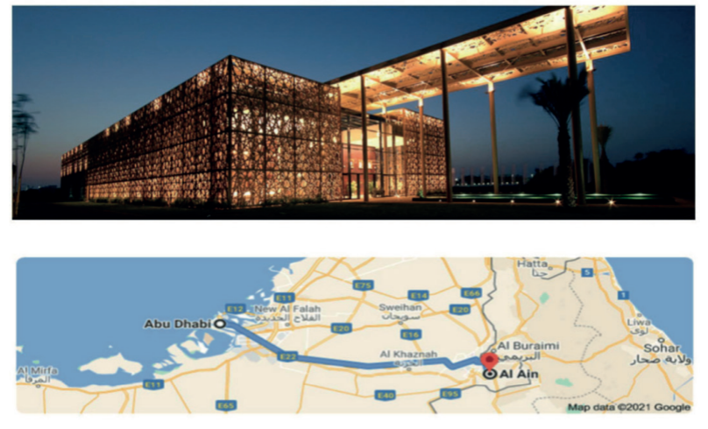
For more details, please contact Tawam Molecular Imaging Centre at 80077.

